Smarter Diabetes Management

GluCurve Pet CGM

Diabetes: It’s Not Just for Humans

In a healthy body, most food once consumed is broken down into sugar (glucose) and released into the bloodstream. The rise in blood glucose triggers the release of the hormone insulin, which is produced in the pancreas and acts as a key allowing glucose to enter cells where it is used for energy.

Diabetes mellitus, DM or diabetes, is a condition that occurs when the body cannot use glucose normally or does not produce appropriate levels of insulin to manage glucose. Dogs are typically Type 1 diabetics and stop producing insulin thus requiring insulin injections for life. Cats are commonly Type 2 diabetics, meaning the body doesn’t use the insulin it produces properly; they too typically require insulin injections but with proper monitoring and regulation can achieve remission.

There is no medical cure for diabetes. However, following a lifestyle characterized by proper weight, physical activity, healthy diet, closely monitoring glucose levels, and strictly following a prescribed care plan can help avoid or prolong co-morbidities, such as cardiovascular disease and renal failure.

Diabetes is a growing concern globally amongst humans, with a congested marketplace dominated by a few players catering to ~537 million diabetics worldwide. Lesser known is the void in veterinary medicine, where millions of pet cats and dogs have diabetes. That’s about 1 in 175 cats and 1 in 300 dogs.

Today’s Standard of Care: A Lose/Lose Scenario

Monitoring a diabetic cat or dog’s glucose levels today typically involves the pet spending 10-12 hours at a veterinary clinic where it will undergo 6-7 blood draws during that span. The high level of stress associated with being in a clinic and getting stuck by a needle result in inaccurate glucose readings. The two-hour gap between each blood draws also misses blood sugar highs and lows, and the readings do not correspond with what a typical day at home would be for the animal.

Each blood draw requires a minimum of two staff members to restrain the animal and collect the blood. The data is manually recorded. Once the draws are completed, an analysis is performed with the data plotted to form a graph known as a “glucose curve” that is meant to provide insight on the disease. It is an antiquated and inefficient process that is unfavorable for all involved and costly for the pet owner.

Veterinarians are so desperate for alternatives that many have turned to using a human Continuous Glucose Monitors (CGMs) off label in a bid to better treat pets. These are not designed for animals, meaning there are no instructional videos, no technical support, and no warranties. The most commonly used human CGM must be scanned every 8 hours or the data is lost. Worse yet, the app and device are designed for humans, rendering most of the data difficult to use, interpret, and share.

GluCurve: The Next Generation in Diabetic Pet Care

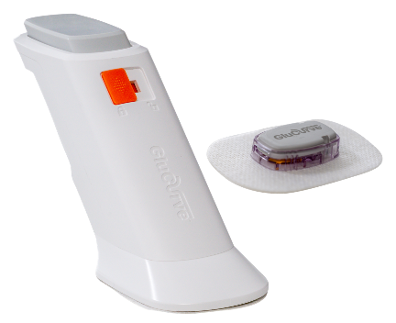
ALRT has developed cutting-edge technology designed for the human diabetes market consisting of FDA-cleared, HIPAA-compliant software that solves the costly, systemic patient self-management
and adherence to care plan problems for the global diabetes population. The company has modified this technology to develop the world’s first CGM and patient management application, branded GluCurve Pet CGM, specifically for the treatment of diabetic cats and dogs.

The hardware is pain-free and easy to apply. It records glucose readings every 3 minutes for up to 14 days and has an onboard memory chip that stores the data the entire 14 days. The data uploads to a mobile device via Bluetooth automatically, every time within range.
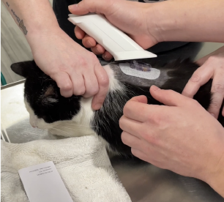
The GluCurve Pet CGM also provides a veterinary web portal for diabetic patient management, automated glucose curve graphs and tables, prescription tracking, comparison and overlay tools, insulin dose calculators, best care guidelines, instructional videos, customer support, remote care options, and more.

The GluCurve app for pet owners that uploads glucose readings to the veterinary portal is compatible with iOS and Android operating systems.

Successful Non-Inferiority Study

In March 2022, ALRT completed a non-inferiority study that showed the efficacy of the GluCurve Pet CGM. The study conclusions were highlighted by the GluCurve Pet CGM proving more accurate that the leading Blood Glucose Meter (BGM) 47.8% of the time. 100% of the GluCurve Pet CGM readings paired to chemistry analyzer reference values were within ±20%, compared to 86.9% from the animal BGM. Average deviation from baseline was 9.7% for the GluCurve unit versus 8.2% for the animal BGM. In short, the study determined there were no clinically significant differences when comparing the GluCurve Pet CGM to the chemistry analyzer or leading animal BGM, a key determination towards commercialization for ALRT.

GluCurve Pet CGM also provided additional critical data that is otherwise unavailable from today’s standard of care, including insulin injection times, eating habits, activity, and stress seen through changes in glucose on a day-to-day basis.

“The GluCurve Pet CGM plugs a long-standing gap in managing veterinary diabetic patients; not only will veterinarians finally receive effortlessly accurate data, the patients will live longer too,”
-Dr. Kip Imperato, lead veterinarian in the GluCurve Pet CGM study

View additional data on the GluCurve Pet CGM study

Vets Love Us

The market researchers at SmartPharma conducted a survey in April 2021 with veterinarians in the U.S. to get a better reading on market demand for a new product such as the GluCurve Pet CGM. An astounding 97% of respondents said they would use the GluCurve Pet CGM.

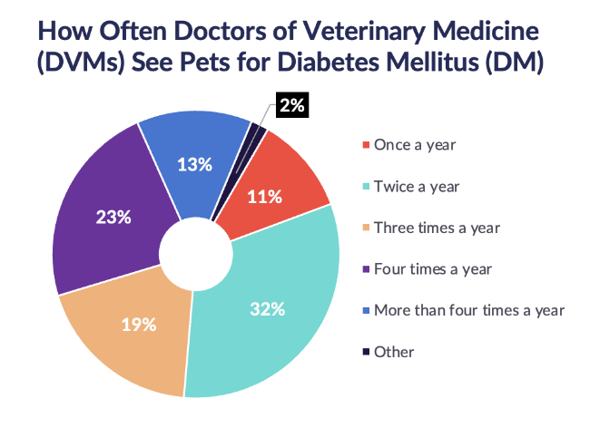
Other valuable information was gleaned from the research, including validation that 2 or more GluCurve Pet CGM’s are needed initially for newly diagnosed diabetic pets and that, on average, three GluCurve Pet CGM’s would be used per year for monitoring current diabetic pets.

ALRT views the estimations as conservative with a view that use rate is expected to grow with consumer and veterinarian exposure due to low cost, ease of use, and accuracy of data.

The research confirmed the high frequency of diabetic pet care, with 36% of veterinarians saying they see their diabetic pet patients four or more times a year.

The Future of Diabetic Pet Care

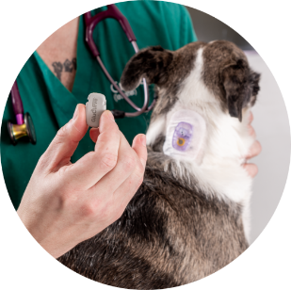
ALRT has now partnered with Covetrus, one of the largest animal health companies in the world, to market and sell the GluCurve Pet CGM directly to veterinary clinics throughout the U.S. and European Union. The GluCurve Pet CGM will be featured in January 2023 at the Consumer Electronics Show (CES) in Las Vegas and at the Veterinary Meeting & Expo (VMX), which is the largest veterinary conference in the world.

ALRT leadership is also seeking collaborations with pharmaceutical companies that manufacture insulin for animals to leverage ALRT’s proprietary, FDA-cleared, AI-based insulin dosing adjustment technology (originally developed for human applications) to explore the opportunity to introduce an insulin dose suggestion feature to its veterinary web portal platform.

ALRT and it’s partners have initiated R&D on the next generation of the GluCurve Pet CGM, an all-in-one model that is smaller, lighter, and has various other improvements. The company is targeting a release date in the second half of 2023.

Get in touch with us at media@ALRT.com.

